**EXPERIMENT 13**

Demonstrate Infrastructure as a Service (IaaS) by creating a Virtual Machine using a Public Cloud Service Provider (Azure), configure with required memory and CPU. first we can sign in into Azure

# home page will appears like this now click on virtual machines

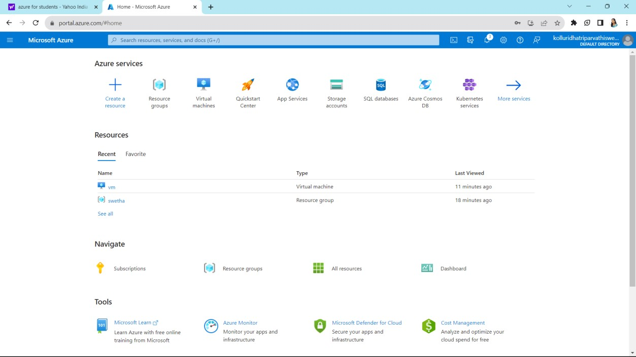

Now click on virtual machines select azure virtual machine and then click on create

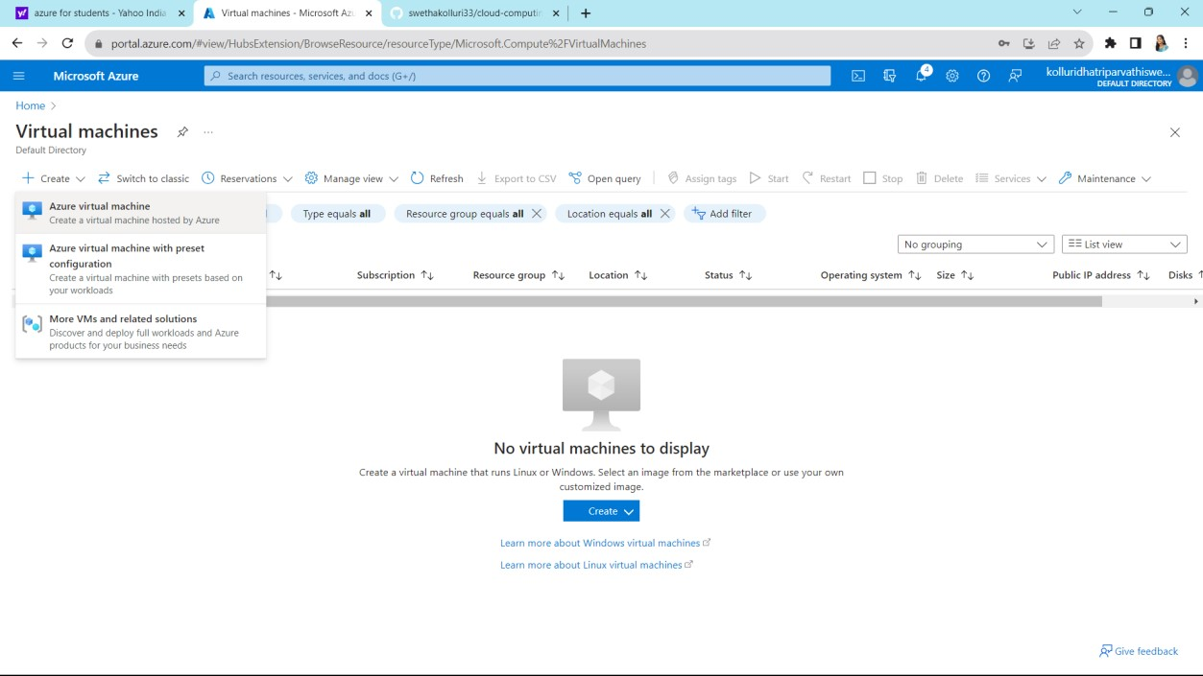

Fill up the requirements

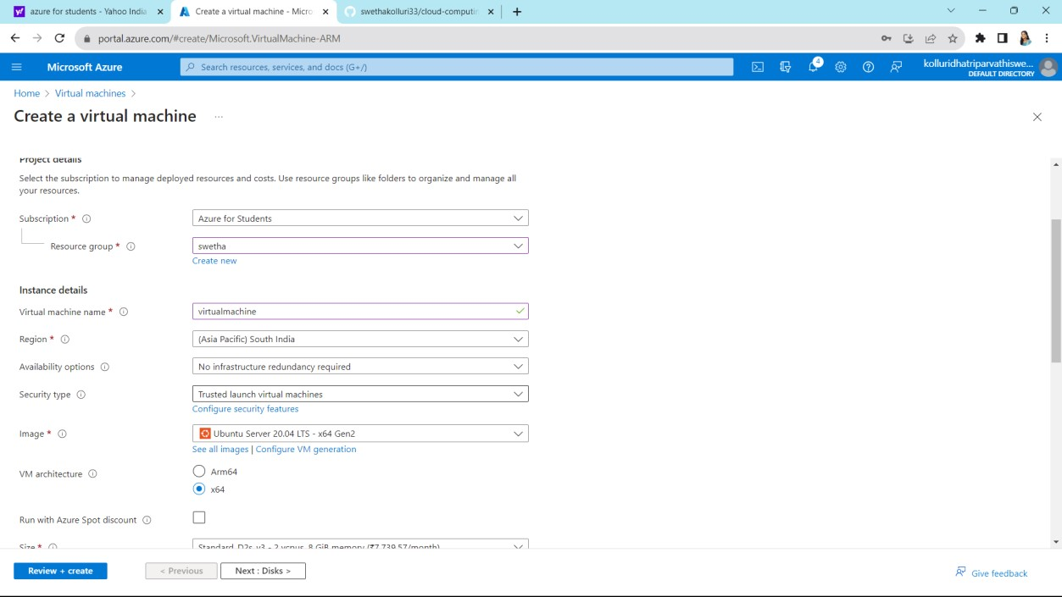

Select password and give a strong password after that click on next

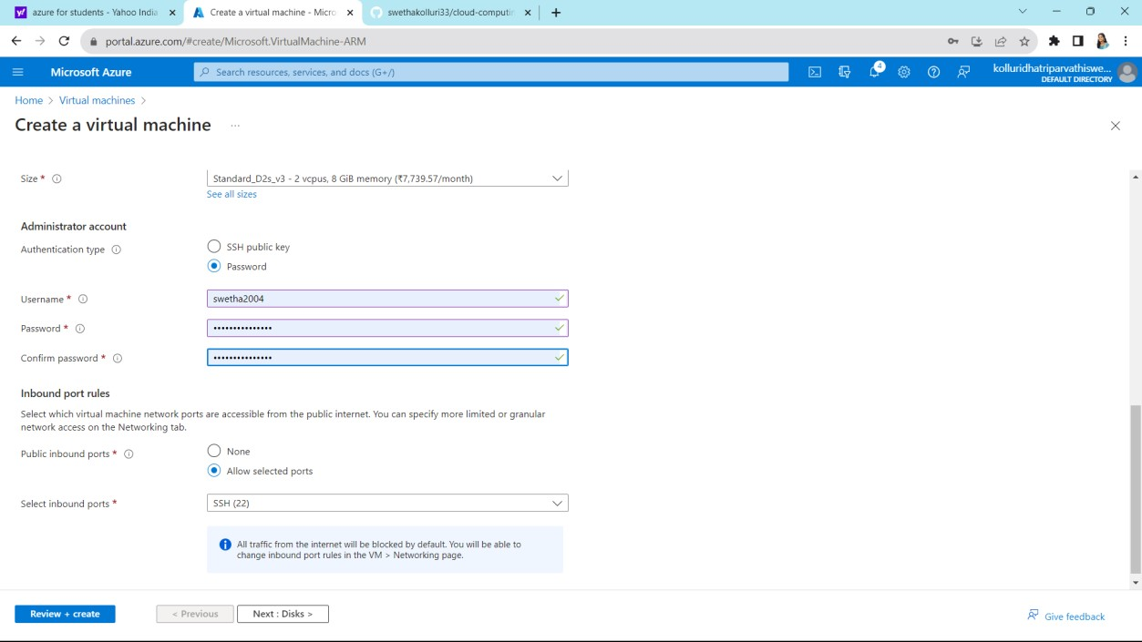

Click on next

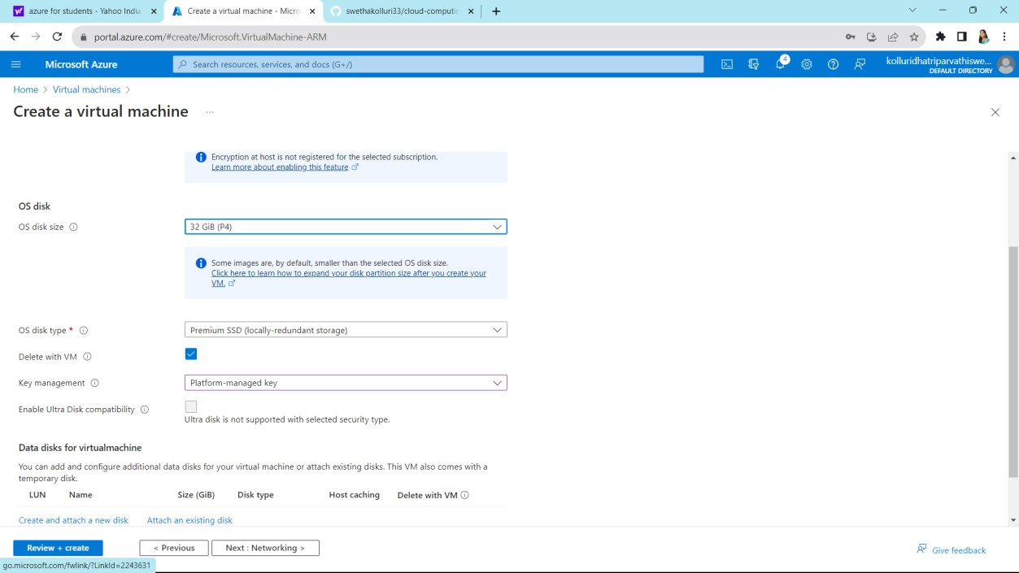

Check the details and click on next

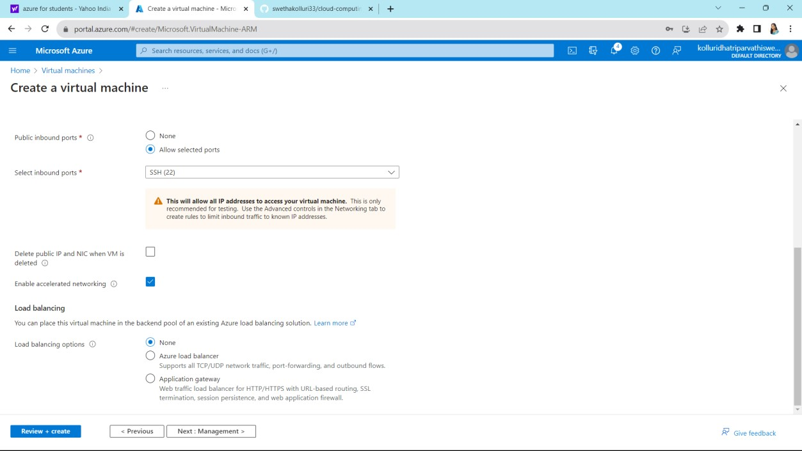

# on next

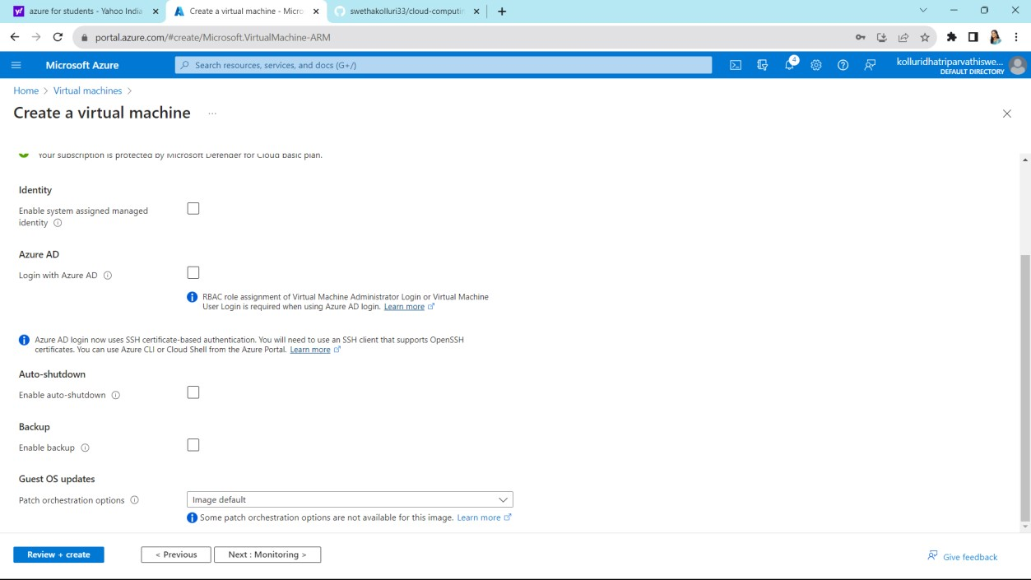

# Click on next

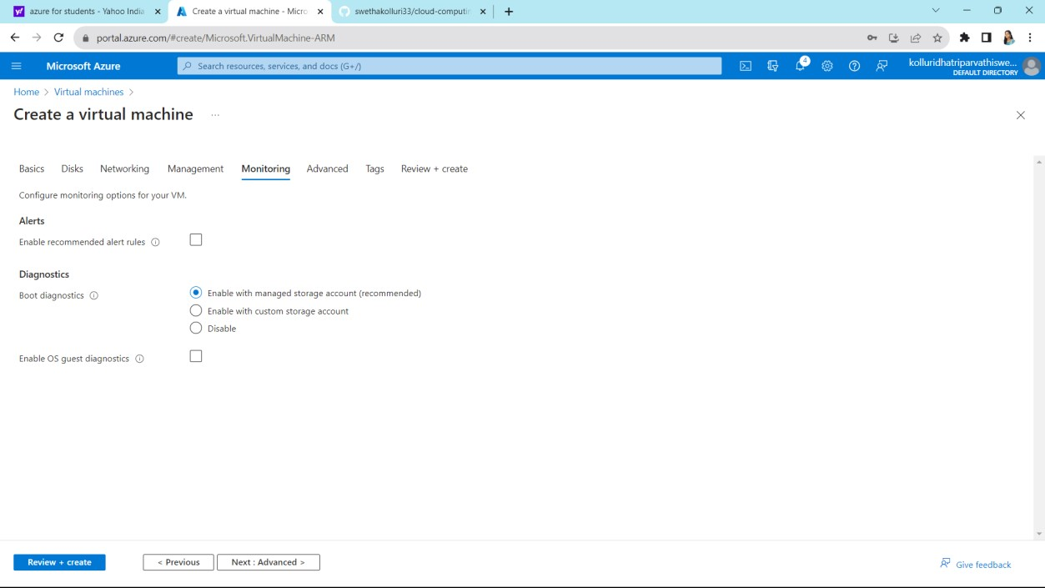

# on next

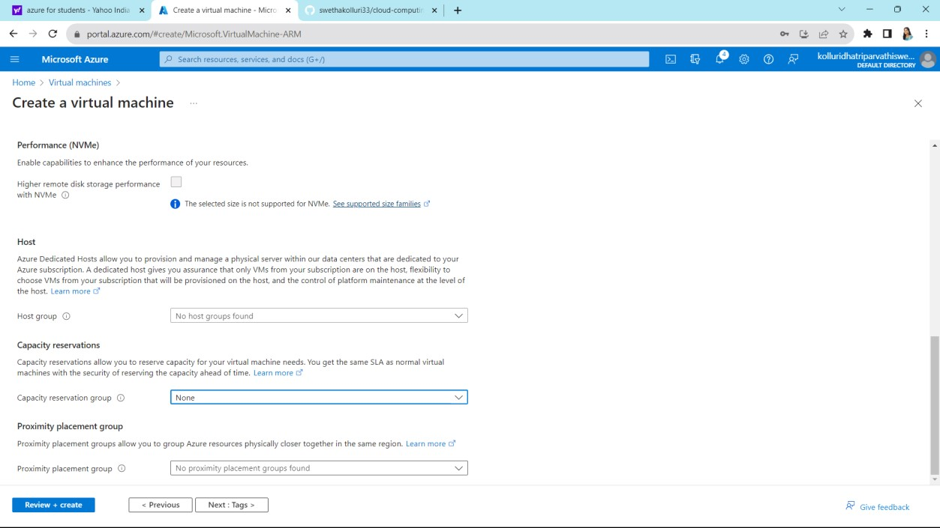

# Give some names and values and click on next

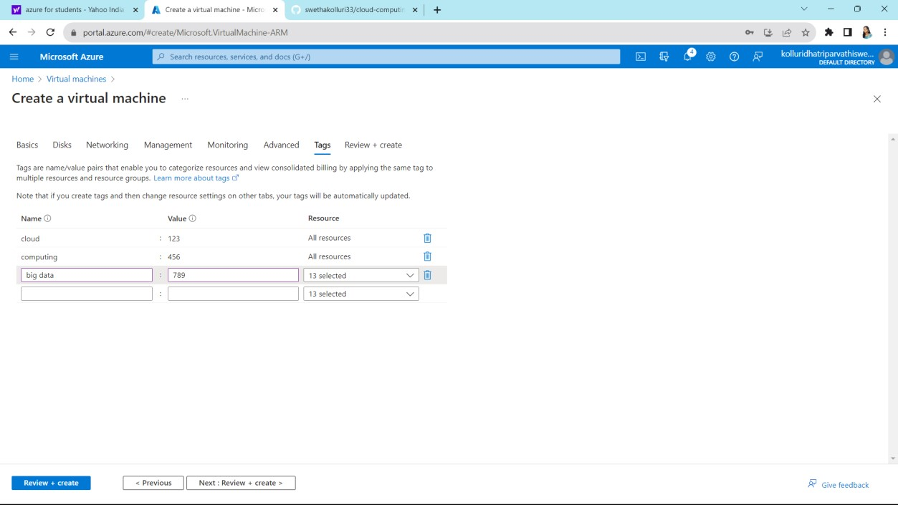

# on create which is on left side bottom

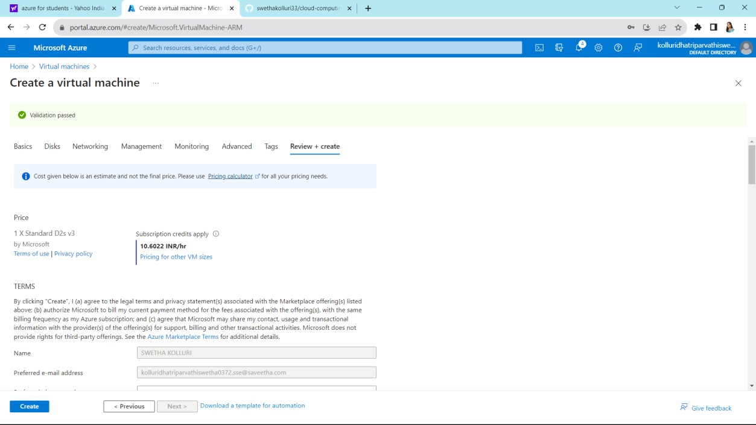

# Click on got resources

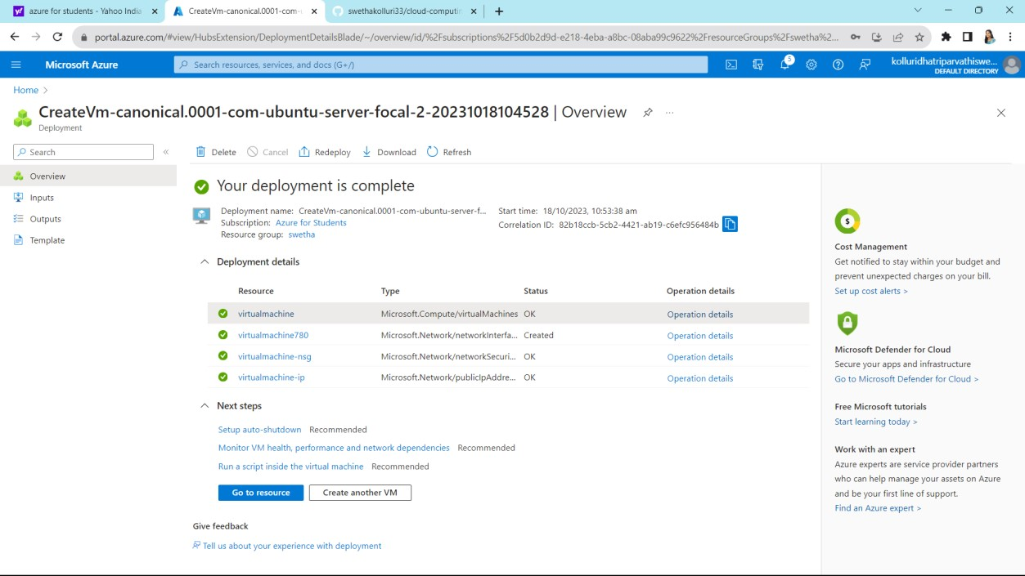

# It shows all you listed before

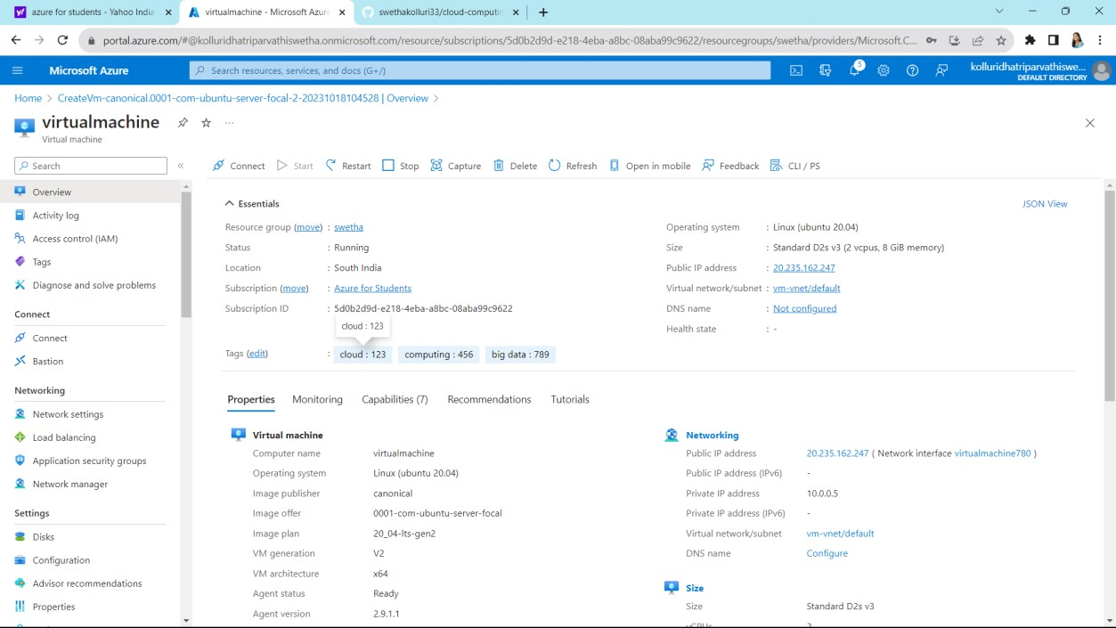

# Go to home created virtual machine is appears at home page

